

**FEDERATION ACCOUNT ALLOCATION COMMITTEE (FAAC) Q1’2020 DISBURSEMENT**



**[](https://twitter.com/kairoscapita_ng)[](https://web.facebook.com/Kairos-Capital-Limited-457426968095854/?__tn__=%2Cd%2CP-R&eid=ARBS7VL0Yus16hHuHmM1InaNpncbMprFG2eUzBxEl1ek1Z-1bGecNO8XfdumLisx2JP74AZfBQsQZY_y&_rdc=1&_rdr)[](https://www.linkedin.com/company/kairoscapitalng/?originalSubdomain=ng)[](https://www.instagram.com/kairoscapitalng/)**

**KAIROS RESEARCH**

The Federation Account Allocation Committee (FAAC) disbursed the sum of N581.57 billion to the three tiers of government in March 2020 from the revenue generated in February 2020.

The amount disbursed comprised of N466.06 billion from the Statutory Account, N15.20 billion from FOREX Equalisation Account, N99.55 billion from Valued Added Tax (VAT) and N757.94 million from Exchange Gain Differences.

Further breakdown of revenue allocation distribution to the Federal Government of Nigeria (FGN) revealed that the sum of N201.92 billion was disbursed to the FGN consolidated revenue account; N4.80 billion shared as share of derivation and ecology fund; N2.40 billion as stabilization fund; N8.06 billion for the development of natural resources; and N6.58 billion to the Federal Capital Territory (FCT) Abuja.

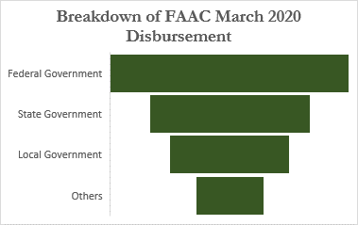

N236.12 bn

N159.01 bn

N119.31 bn

N67.14bn

FAAC has shared the sum of N1.945 trillion in Q1 2020 which is the highest Q1 disbursement since 2014. The disbursements since 2015 were N1.648 trillion in Q1 2015, N1.132 trillion in Q1 2016, N1.411 trillion in Q1 2017, N1.938 trillion in Q1 2018, and N1.929 trillion in Q1 2019.

The highest disbursement was in Q1 2014 while the lowest disbursement was in Q1 2016 which can be attributed to the N345.10 billion received as FAAC in March 2016; the lowest monthly FAAC recorded between 2014 to Q1 2020.

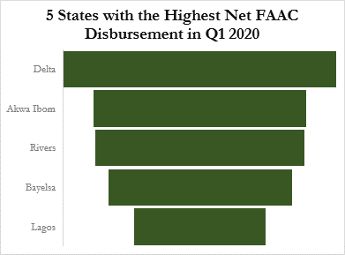

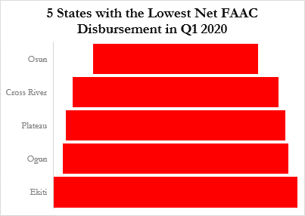

N52.03 bn

N6.44 bn

N40.61 bn

N8.01 bn

N39.99 bn

N8.53 bn

N8.76 bn

N35.14 bn

N9.46 bn

N25.23 bn

**Source: National Bureau of Statistics (NBS), Kairos Capital Research**

Delta state received the most net FAAC in Q1 2020 higher than the combined receipts by Osun, Cross River, Plateau, Ogun, Ekiti and Gombe. The combined distribution to the 5 highest states totaled N192.99 billion against the distribution to the 5 lowest states N41.19 billion.

respectively.

According to the NBS report, 31 states received less than N20 billion as total net FAAC disbursements in Q1 2020 while only five states received more than N20 billion. These States are Lagos (N26.23 billion), Bayelsa (N35.14 billion), Rivers (N39.99 billion), Akwa Ibom (N40.61 billion), and Delta (N52.03 billion), who received 4.52%, 6.29%, 7.16%, 7.27% and 9.31% of total net FAAC disbursements respectively.

**Source: National Bureau of Statistics (NBS), Kairos Capital Research**

For enquiries, please contact us@ Email: [info@kairoscapitalng.com](mailto:info@kairoscapitalng.com) Tel: +234(0) 908 748 2175 Follow us on: [](https://twitter.com/kairoscapita_ng) [](https://www.facebook.com/Kairos-Capital-Limited-457426968095854/?__tn__=,d,P-R&eid=ARBS7VL0Yus16hHuHmM1InaNpncbMprFG2eUzBxEl1ek1Z-1bGecNO8XfdumLisx2JP74AZfBQsQZY_y) [](https://www.linkedin.com/company/kairoscapitalng/?originalSubdomain=ng) [C:\Users\funmilayo.agbajelola\AppData\Local\Microsoft\Windows\INetCache\Content.MSO\19F6809C.tmp](https://www.instagram.com/kairoscapitalng/)